Practice problems for chapter 5:

R3. What are some of the possible services that a link-layer protocol can offer to the network layer? Which of these link-layer services have corresponding services in IP? In TCP?

R11. Why is an ARP query sent within a broadcast frame? Why is an ARP response sent within a frame with a specific destination MAC address?

R4. Suppose two nodes start to transmit at the same time a packet of length L over a broadcast channel of rate R. Denote the propagation delay between the two nodes as dprop. Will there be a collision if dprop < L/R? Why or why not?

P11. Suppose four active nodes—nodes A, B, C and D—are competing for access to a channel using slotted ALOHA. Assume each node has an infinite number of packets to send. Each node attempts to transmit in each slot with probability p. The first slot is numbered slot 1, the second slot is numbered slot 2, and so on.
- What is the probability that node A succeeds for the first time in slot 5?
- What is the probability that some node (eitherA,B,CorD) succeeds in slot 4?
- What is the probability that the first success occurs in slot 3?
- What is the efficiency of this four-node system?

P18. Suppose nodes A and B are on the same10Mbps broadcast channel, and the propagation delay between the two nodes is 325 bit times. Suppose CSMA/CD and Ethernet packets are used for this broadcast channel. Suppose node A begins transmitting a frame and, before it finishes, node B begins transmitting a frame. Can A finish transmitting before it detects that B has transmitted? Why or why not? If the answer is yes, then A incorrectly believes that its frame was success- fully transmitted without a collision. Hint: Suppose at time t = 0 bits, A begins transmitting a frame. In the worst case, A transmits a minimum-sized frame of 512 + 64 bit times. So A would finish transmitting the frame at t = 512 + 64 bit times. Thus, the answer is no, if B’s signal reaches A before bit time t = 512 + 64 bits. In the worst case, when does B’s signal reach A?

P31. In this problem, you will put together much of what you have learned about Internet protocols. Suppose you walk into a room, connect to Ethernet, and want to download a Web page. What are all the protocol steps that take place, starting from powering on your PC to getting the Web page? Assume there is nothing in our DNS or browser caches when you power on your PC. (Hint: the steps include the use of Ethernet, DHCP, ARP, DNS, TCP, and HTTP protocols.) Explicitly indicate in your steps how you obtain the IP and MAC addresses of a gateway router.

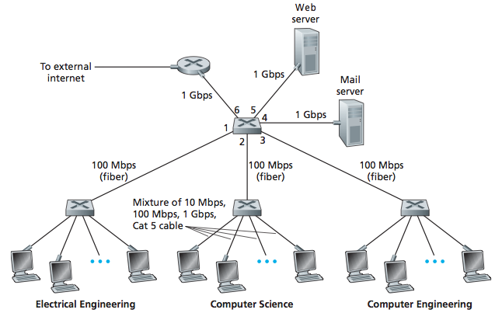

P23. Consider the above figure. Suppose that all links are 100 Mbps. What is the maxi- mum total aggregate throughput that can be achieved among the 9 hosts and 2 servers in this network? You can assume that any host or server can send to any other host or server. Why?

P24. Suppose the three departmental switches in above figure are replaced by hubs. All links are 100 Mbps. Now answer the questions posed in problem P23.

P25. Suppose that all the switches in the above figure are replaced by hubs. All links are 100 Mbps. Now answer the questions posed in problem P23.

